Inauguration of NMAMIT-Student Chapter activities of Condition Monitoring Society of India (CMSI-Vishakhapatnam) for the year 2016-17.
Condition Monitoring Society of India (CMSI-Vishakhapatnam) NMAMIT Chapter activities for the year 2016-17 were inaugurated on 29th September 2016, in the Phalguni seminar hall at 3.00 PM. Mr. S. Girish, Joint General Manager - Plant Maintenance, MCF Mangalore was the Chief Guest for the function. The function started with invocation by Mr. Divijesh P. Faculty, Department of Mechanical Engineering followed by welcome speech and a brief introduction about CMSI by Mr. Dilip Kumar K, the Coordinator of CMSI Chapter. The chief guest gave a technical talk about Maintenance Management in MCF. This was followed by presidential remarks by Principal Dr. Niranjan N. Chiplunkar. He gave suggestions to CMSI chapter members to visit Vishakhapatnam. The function concluded with a vote of thanks by Mr. Dilip Kumar K. Vice-Principal and Dean-Academics Dr. I R Mithanthaya, Dean-Student Welfare Dr. Subrahmanya Bhat K, Faculty from the Mechanical Engineering Department and about 36 student members were present.
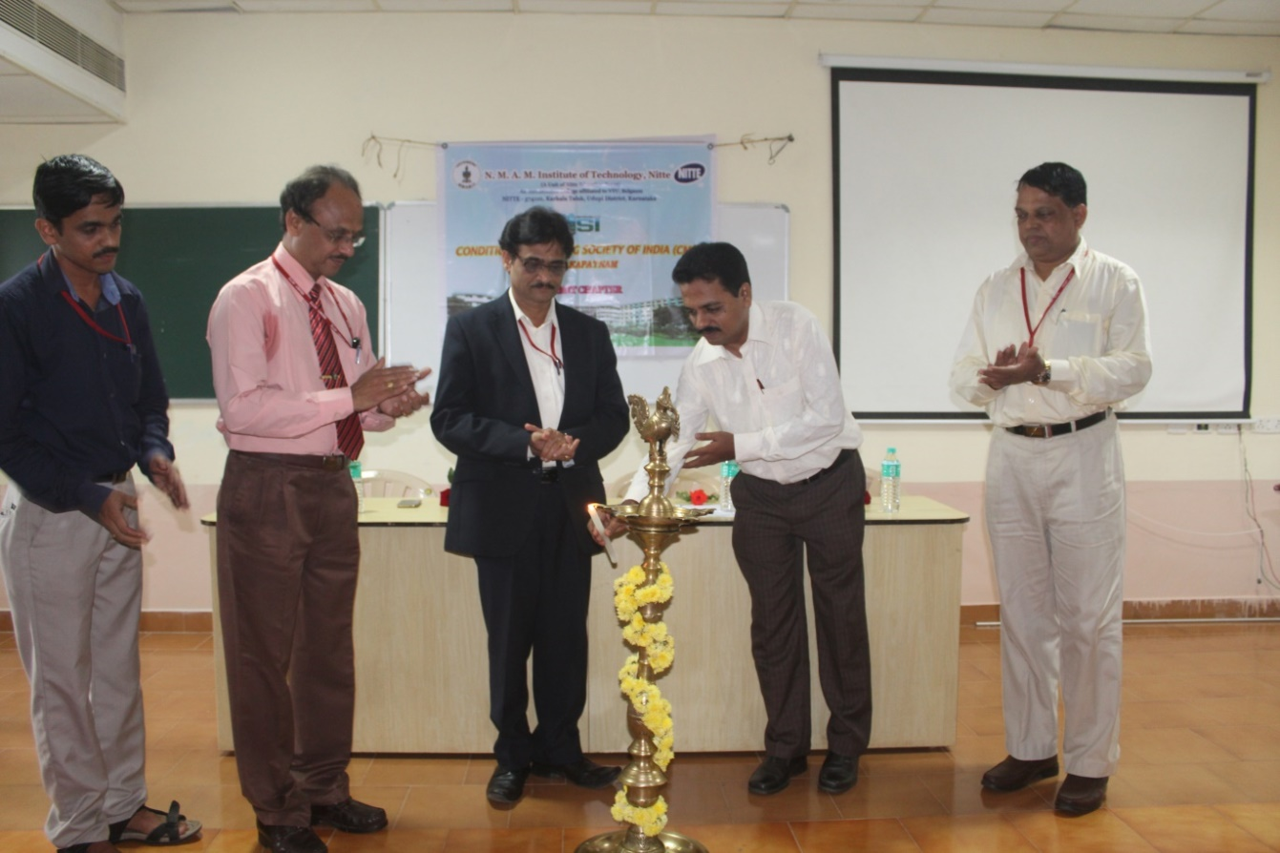

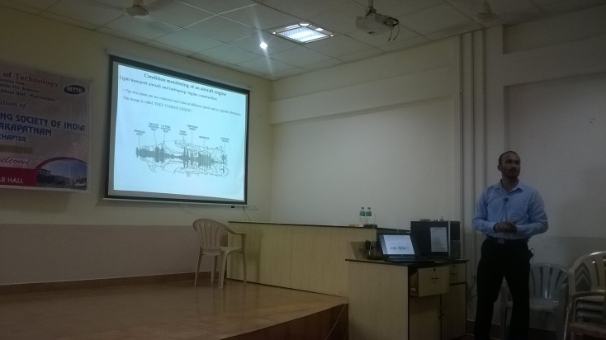
A Technical Talk was arranged by CMSI-Vishakapatnam, NMAMIT Chapter on the topic “An overview of vibration based condition monitoring of aircraft engine and wind turbine drive train “. It was delivered by Mr. Wilbur G. Fernandes (Condition Monitoring & Analytics Engineer-Global Service, from Vestas Wind Technology India Pvt. Ltd., Chennai) on 13-04-2017 at Phalguni Seminar hall of NMAMIT. Mr. Wilbur touched upon various practical issues related to condition monitoring of aircraft engines and wind turbines. He also spoke about the significance of Vibration certification course and its importance in industries.
The talk was attended by Dean-Students welfare Dr. Subrahmanya Bhat, Mechanical H.O.D. Dr. Shashikanth Karinka, Professor Dr. Srinivasa Pai P., Other staff of mechanical department, MTech and BTech students and CMSI members.

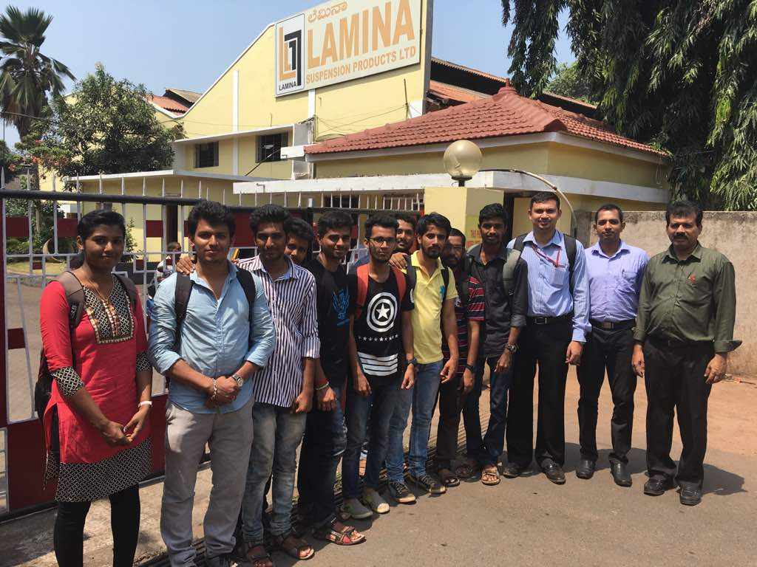

A industry visit to Lamina Suspension Products Ltd., was arranged by CMSI-Vishakapatnam, NMAMIT Chapter on 29 April 2017. Eleven CMSI student members of MTech-Machine Design stream along with four staff of NMAMIT Mechanical department visited Lamina suspensions. The manufacturing activities of Lamina brand suspension springs was demonstrated to students. They were also explained of the functioning of newly introduced Robotic manufacturing of suspension springs with the live demonstrations.

